HOENIX NEW LIFE POETRY
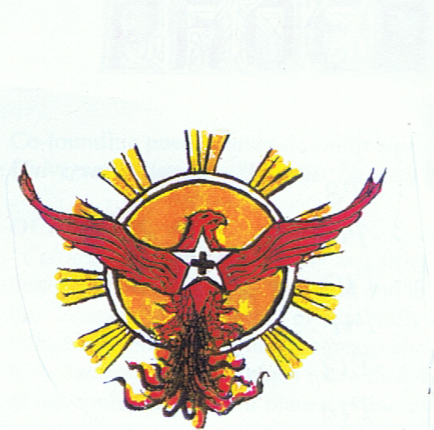

& NEW WORLD CREATION PROJECT NEWS & REVIEWS A quarterly, international journal for engaged poets of the New Millennium with a positive, eutopian, spiritual & wholistic social vision for humanity & the Planetary Creation of which we are a part, as its trustees & custodians, in the spirit of Percy Bysshe Shelley, William Blake & Allen Ginsberg

SUMMER 2021

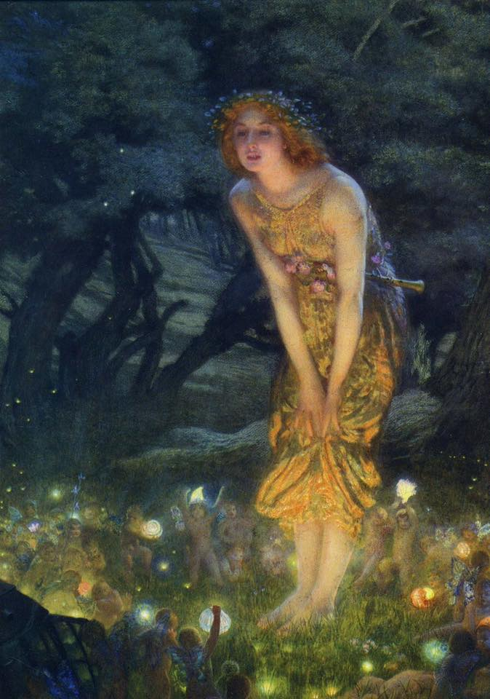

Ravenous Butterflies
“If you come as softly As wind within the trees You may hear what I hear, See what sorrow sees.”

